|  |
| --- |
| **Name: Keerthana P**  **Roll No: 12**  **Batch: MCA-B**  **Date: 01/09/2022** |

**DATA SCIENCE LAB**

**Aim**

Programs using matplotlib / plotly / bokeh / seaborn for data visualisation.

**Procedure**

# Line graph

import matplotlib.pyplot as plt

x = [1, 2, 3, 4, 5, 6, 7, 8, 9] y1 = [1, 3, 5, 3, 1, 3, 5, 3, 1] y2 = [2, 4, 6, 4, 2, 4, 6, 4, 2] plt.plot(x, y1, label="line L") plt.plot(x, y2, label="line H")

plt.plot()

plt.xlabel("x axis") plt.ylabel("y axis") plt.title("Line Graph Example")

plt.legend()

plt.show()

# Output

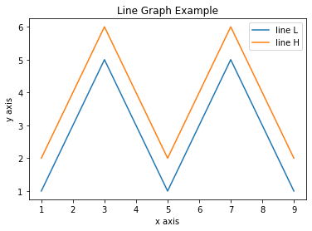

# Bar chart

import matplotlib.pyplot as plt

x1 = [1, 3, 4, 5, 6, 7, 9] y1 = [4, 7, 2, 4, 7, 8, 3] x2 = [2, 4, 6, 8, 10] y2 = [5, 6, 2, 6, 2]

plt.bar(x1, y1, label="Blue Bar", color='y') plt.bar(x2, y2, label="Green Bar", color='r')

plt.plot()

plt.xlabel("bar number") plt.ylabel("bar height") plt.title("Bar Chart Example") plt.legend()

plt.show()

# Output

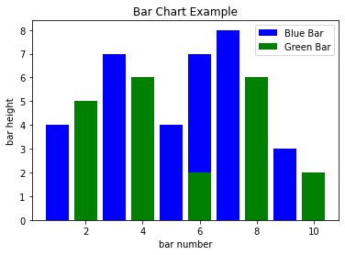

# Raw Data, Histogram and Cumulative Histogram

import matplotlib.pyplot as plt import numpy as np

n = 5 + np.random.randn(1000)

m = [m for m in range(len(n))]

plt.bar(m, n) plt.title("Raw Data") plt.show()

plt.hist(n, bins=20) plt.title("Histogram")

plt.show()

plt.hist(n, cumulative=True, bins=20) plt.title("Cumulative Histogram") plt.show()

# Output

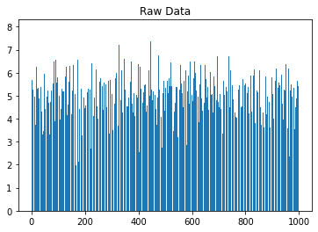

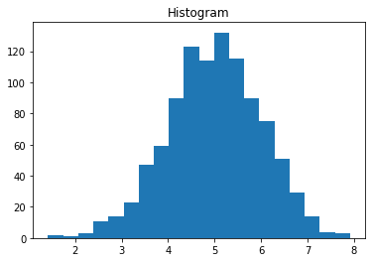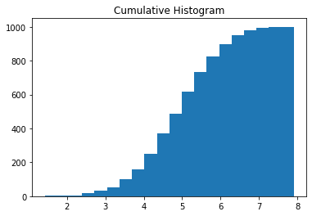

# Scatter Plot

import matplotlib.pyplot as plt

x1 = [2, 3, 4] y1 = [5, 5, 5] x2 = [1, 2, 3, 4, 5] y2 = [2, 3, 2, 3, 4] y3 = [6, 8, 7, 8, 7]

plt.scatter(x1, y1) plt.scatter(x2, y2, marker='v', color='y') plt.scatter(x2, y3, marker='^', color='r') plt.title('Scatter Plot Example') plt.show()

# Output

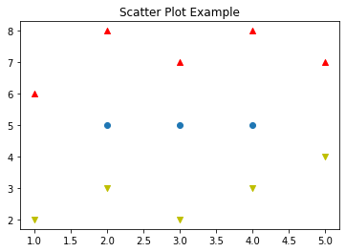

**Box plot** plt.figure()

plt.suptitle("Boxplot for X vs Y split into 5 bins") ax = plt.gca()

df2.boxplot(showmeans=True) # Rotate x axis text values for tick in ax.get_xticklabels():

tick.set_rotation(30)

print("\nIn the boxplot below, the box extends from the lower to upper quartile values of the data, with a line at the median.\n \

The whiskers extend from the box to show the range of the data. The triangle indicates the mean value.\ n")

# Output

In the boxplot below, the box extends from the lower to upper quartile values of the data, with a line at the median.

The whiskers extend from the box to show the range of the data. The triangle indicates the mean value.

